June 2021
AirSept – Dual Recycle Guard™ with Quick Connect Fittings
150 word limit
Draft: H
Word Count: 150
America’s 164,000 auto repair facilities rank A/C service as a top five customer request.
AirSept’s new Dual Recycle Guard™ provides greater filtration capacity for fast, effective, reliable protection from damaging sealants and contaminants for all A/C recycling, recovery and recharging equipment.
Introduced in 2021, AirSept’s Dual Recycle Guard’s™ Quick Connect System solves previous installation challenges. Engineered for compatibility with all R134a and R1234yf A/C service machines, Dual Recycle Guard shields both high and low sides simultaneously while trapping sealant, dye, metal shavings, debris, excess lubricant and other contaminants. Recovery time remains constant and only pure refrigerant enters the service equipment.
Dual Recycle Guard comes equipped with fittings, hoses and quick connect service couplers for fast, easy installation. Expensive R134a or R1234yf recycling equipment is protected in a matter of seconds. Dual Recycle Guard helps avoid costly repairs, equipment downtime and lost service profits while maximizing bay turn production and efficiency.

Images Attached:

Image 1: 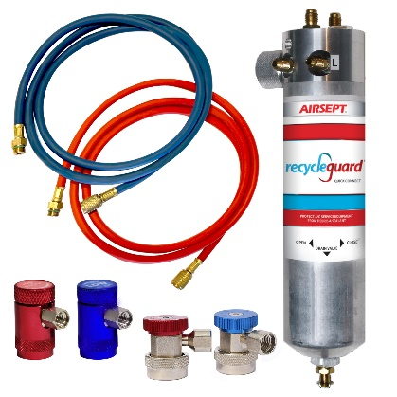
Image 2: (Danielle will provide)

